Final Project Report Template
- Introduction
  - Project overviews
  - Objectives
- Project Initialization and Planning Phase
  - Define Problem Statement
  - Project Proposal (Proposed Solution)
  - Initial Project Planning
- Data Collection and Preprocessing Phase
  - Data Collection Plan and Raw Data Sources Identified
  - Data Quality Report
  - Data Preprocessing


- Model Development Phase
  - Model Selection Report
  - Initial Model Training Code, Model Validation and Evaluation Report
- Model Optimization and Tuning Phase
  - Tuning Documentation
  - Final Model Selection Justification
- Results
  - Output Screenshots
- Advantages & Disadvantages
- Conclusion
- Future Scope
- Appendix
  - Source Code
  - GitHub & Project Demo Link

Natural Language Interfaces for Databases

1. Introduction
1.1 Project Overview:
Natural Language Interfaces for Databases (NLIDB) is a system that allows users to interact with databases using natural language instead of complex query languages like SQL or MongoDB queries. The system converts human language questions into database queries and retrieves the corresponding results.
This project aims to make database interaction simpler, faster, and more accessible for users who do not have knowledge of database query languages. By using Natural Language Processing (NLP) techniques, the system understands user input such as:
- “Show all students”
- “Find students with marks greater than 80”
- “Display students from CSE department”
The system then automatically converts these inputs into MongoDB queries and retrieves the appropriate data from the database.
A user-friendly web interface built using Streamlit allows users to interact with the system easily.
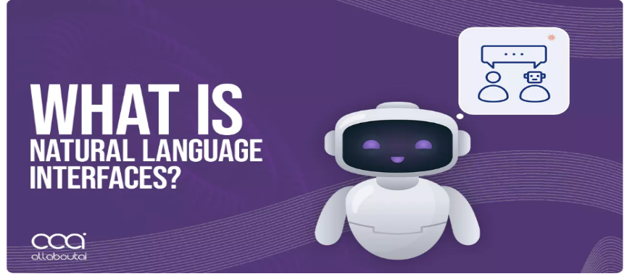
1.2 Objectives :
The main objectives of the project are:
- Simplify Database Interaction
Allow users to query databases using natural language instead of writing complex database queries.
- Improve Accessibility
Help non-technical users interact with databases without prior knowledge of MongoDB or SQL.
- Efficient Query Processing
Convert natural language queries into valid MongoDB queries automatically.
- Interactive User Interface
Provide an easy-to-use web interface where users can ask questions and view results instantly.
- Real-Time Data Retrieval
Fetch and display database results quickly based on user input.


2. Project Initialization and Planning Phase
2.1 Define Problem Statement :
Modern databases store huge amounts of data, but accessing this information often requires knowledge of database query languages such as SQL or MongoDB queries. Many users, especially non-technical users, find it difficult to write these queries.
This creates a gap between users and database systems, making it challenging to retrieve information quickly.
The problem is to develop a system that allows users to interact with databases using natural language queries, eliminating the need to learn complex database syntax.
Key Problems Addressed:
- Difficulty in writing database queries.
- Lack of technical knowledge among users.
- Time-consuming manual query writing.

2.2 Project Proposal (Proposed Solution) :
The proposed solution is to build a Natural Language Interface for MongoDB Database that translates user questions into MongoDB queries.
The system will include:
1. Natural Language Processing
The system will process user input and extract keywords and intent.
2. Query Generation
User questions will be converted into MongoDB queries automatically.
Example:
User Input:
Show students with marks greater than 80
Generated MongoDB Query:
db.students.find({"marks": {"$gt": 80}})
3. Database Integration
MongoDB will store the dataset (student information).
4. User Interface
A Streamlit web application will allow users to enter queries and view results.

2.3 Initial Project Planning :
Project Milestones
1. Requirement Analysis
- Identify system requirements
- Define project scope
Deliverable: Requirement document

2. System Design
- Design system architecture
- Plan database schema
- Design UI
Deliverable: Design documentation

3. Development Phase
- Implement NLP logic
- Connect MongoDB database
- Develop Streamlit interface
Deliverable: Working prototype

4. Testing Phase
- Test query accuracy
- Verify database connectivity
- Fix errors
Deliverable: Tested system

5. Deployment
- Run the application locally
- Demonstrate project functionality
Deliverable: Fully working application

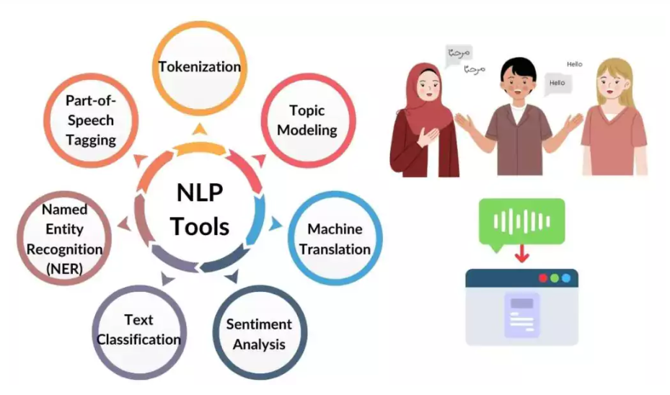
3. Data Collection and Preprocessing Phase
3.1 Data Collection Plan and Raw Data Sources :
For this project, a student dataset is used.
Data Fields
The dataset includes:
- Student ID
- Name
- Department
- Marks
- Age
Data Source
The data is stored in a MongoDB database collection named "students".
Example document:
{
"name": "Rahul",
"department": "CSE",
"marks": 85,
"age": 21
}
Data Collection Method
Data is manually inserted into MongoDB using:
- MongoDB Compass
- MongoDB Shell
- Python scripts
3.2 Data Quality Report :
The dataset was evaluated using the following criteria:
Completeness
All student records contain required fields such as name, department, marks, and age.
Consistency
Data formats were standardized.
Example:
Department values such as:
CSE
ECE
EEE
Accuracy
Data values were verified before insertion.
Duplication
Duplicate records were removed.

3.3 Data Preprocessing :
The preprocessing steps include:
- Cleaning the dataset
- Removing duplicate entries
- Standardizing text values
- Formatting numeric fields

4. Model Development Phase
4.1 Model Selection Report :
The project uses Natural Language Processing techniques instead of traditional machine learning models.
The system processes user input using rule-based logic to identify keywords such as:
- show
- find
- greater than
- less than
- department
These keywords are then mapped to MongoDB query operators.
Example mapping:
Natural Language | MongoDB Operator
greater than | $gt
less than | $lt
equal to | $eq
This approach is lightweight and suitable for small database systems.

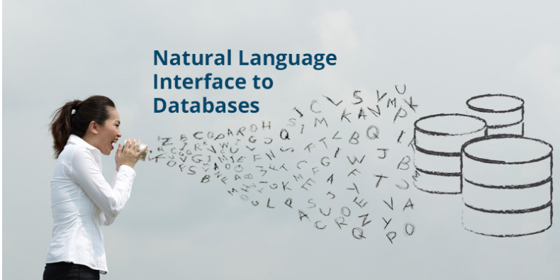
4.2 Initial Model Training Code, Validation and Evaluation
The system processes user queries and converts them into MongoDB queries.
Example code snippet:
def generate_query(user_input):
if "greater than" in user_input:
return {"marks": {"$gt": value}}
The generated query is then executed on MongoDB using Python.

Libraries Used
- Python
- Streamlit
- PyMongo
- python-dotenv

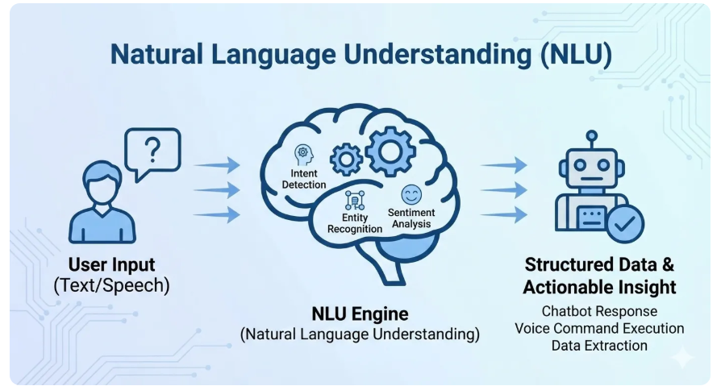
5. Model Optimization and Tuning Phase
5.1 Tuning Documentation :
Optimization techniques used:
- Improved keyword detection
- Added more query patterns
- Handled multiple user inputs
- Reduced processing time

5.2 Final Model Selection Justification :
The rule-based NLP approach was selected because:
- It is simple and lightweight
- Easy to implement
- Requires minimal training data
- Works efficiently for structured queries


6. Results :
The system successfully converts natural language queries into MongoDB queries and retrieves data.
Example Query:
User Input:
Show students from CSE department
Output:
List of students belonging to the CSE department.

6.1 Output Screenshots :
Include screenshots of:
- Application Home Page:
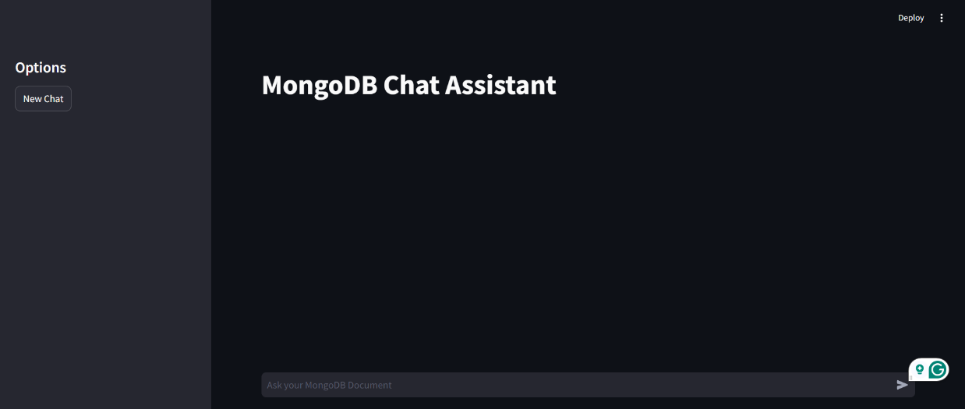

- User Query Input:

- Generated Query:
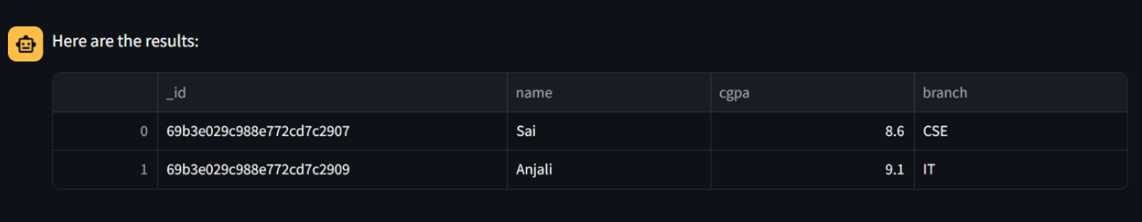

- Database Results:

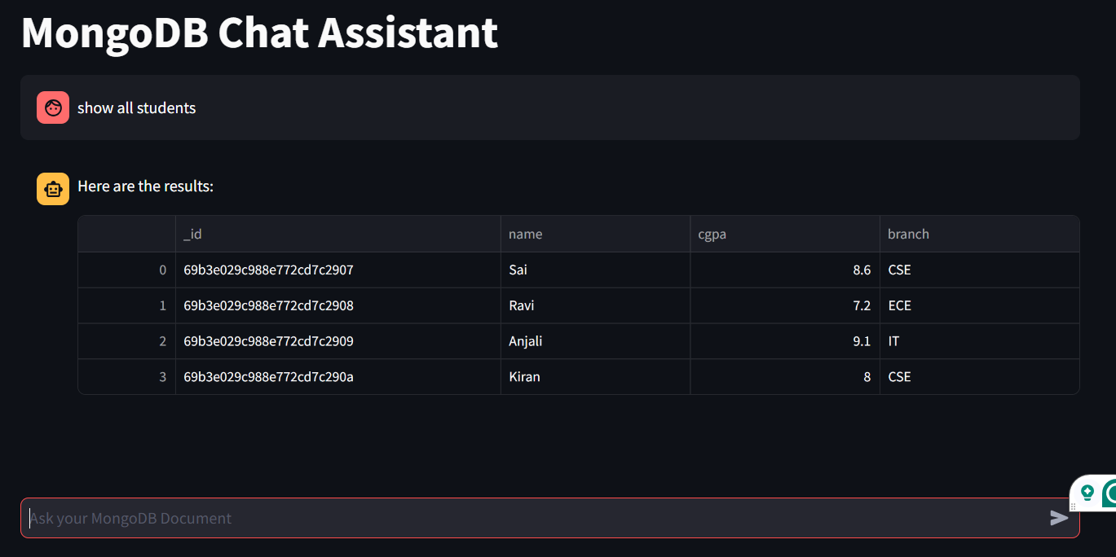

7. Advantages & Disadvantages :
Advantages :
- Easy database interaction
- No need to learn database query languages
- Faster data retrieval
- User-friendly interface
- Accessible for non-technical users

Disadvantages :
- Limited query complexity
- Requires predefined query patterns
- May not understand very complex sentences
- Limited dataset support

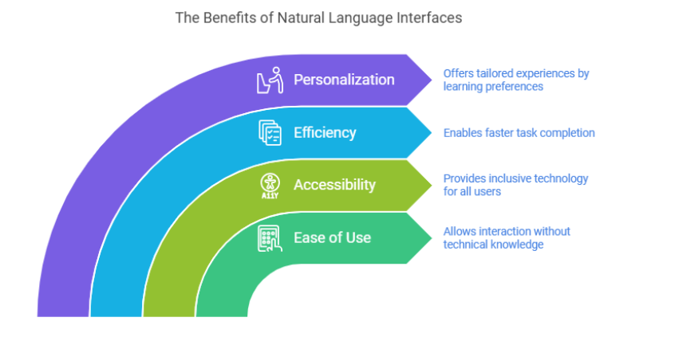
8. Conclusion :
The Natural Language Interface for Databases project demonstrates how natural language processing can simplify database interactions.
By converting user questions into MongoDB queries, the system allows users to retrieve data easily without writing complex queries.
The project successfully integrates Python, MongoDB, and Streamlit to provide a user-friendly interface for database querying.
This approach improves accessibility and efficiency for users who lack technical knowledge of database systems.

9. Future Scope :
Future improvements include:
- Integration with large language models
- Support for multiple databases
- More complex query understanding
- Voice-based database querying
- Deployment as a web application

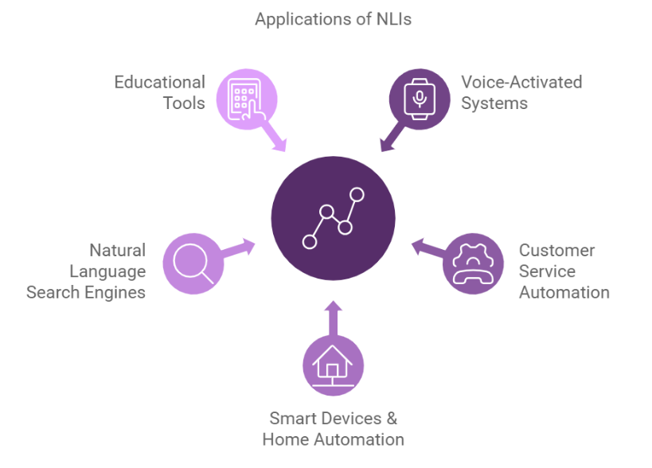
10. Appendix :
10.1 Source Code :
The source code includes:
- app.py
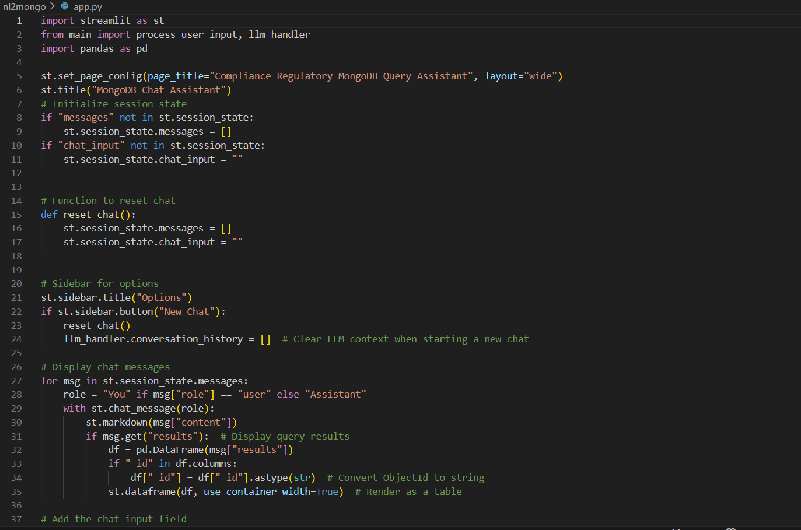
- main.py
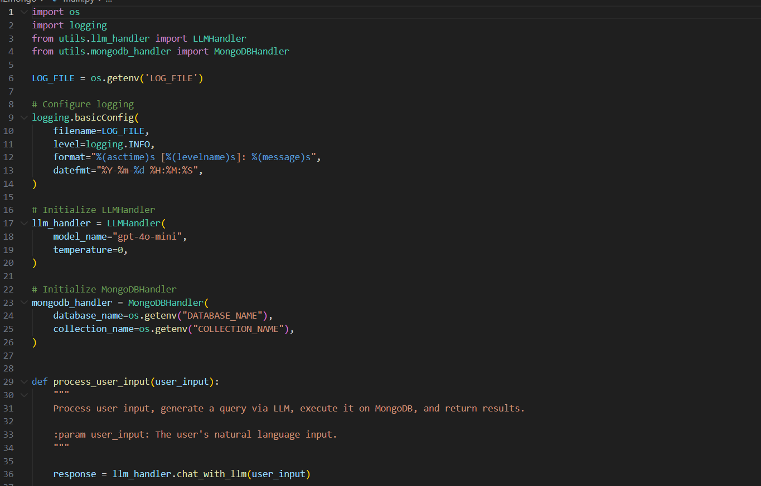

- llm_handler.py
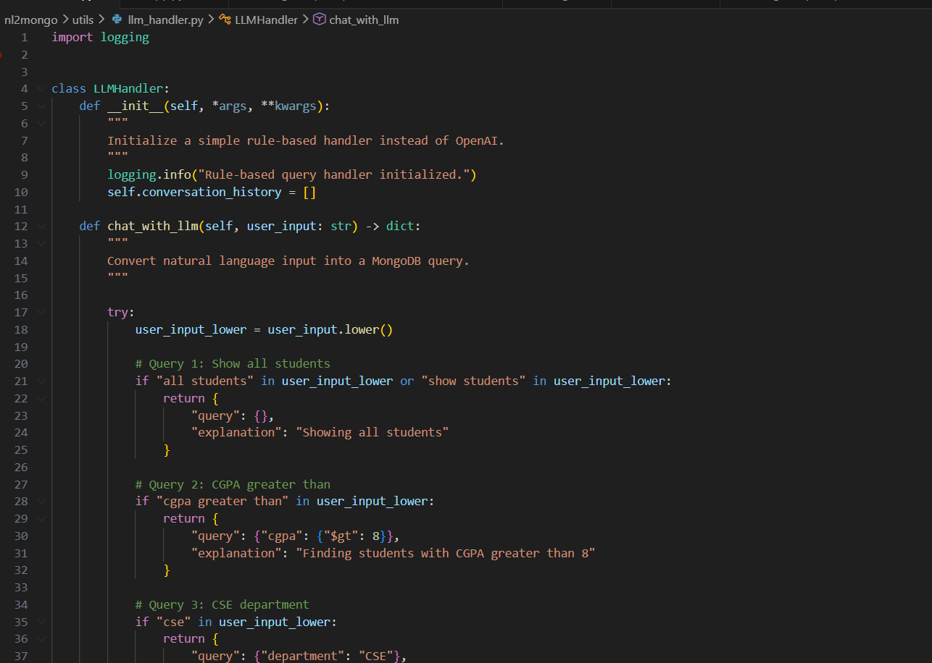
- database_handler.py
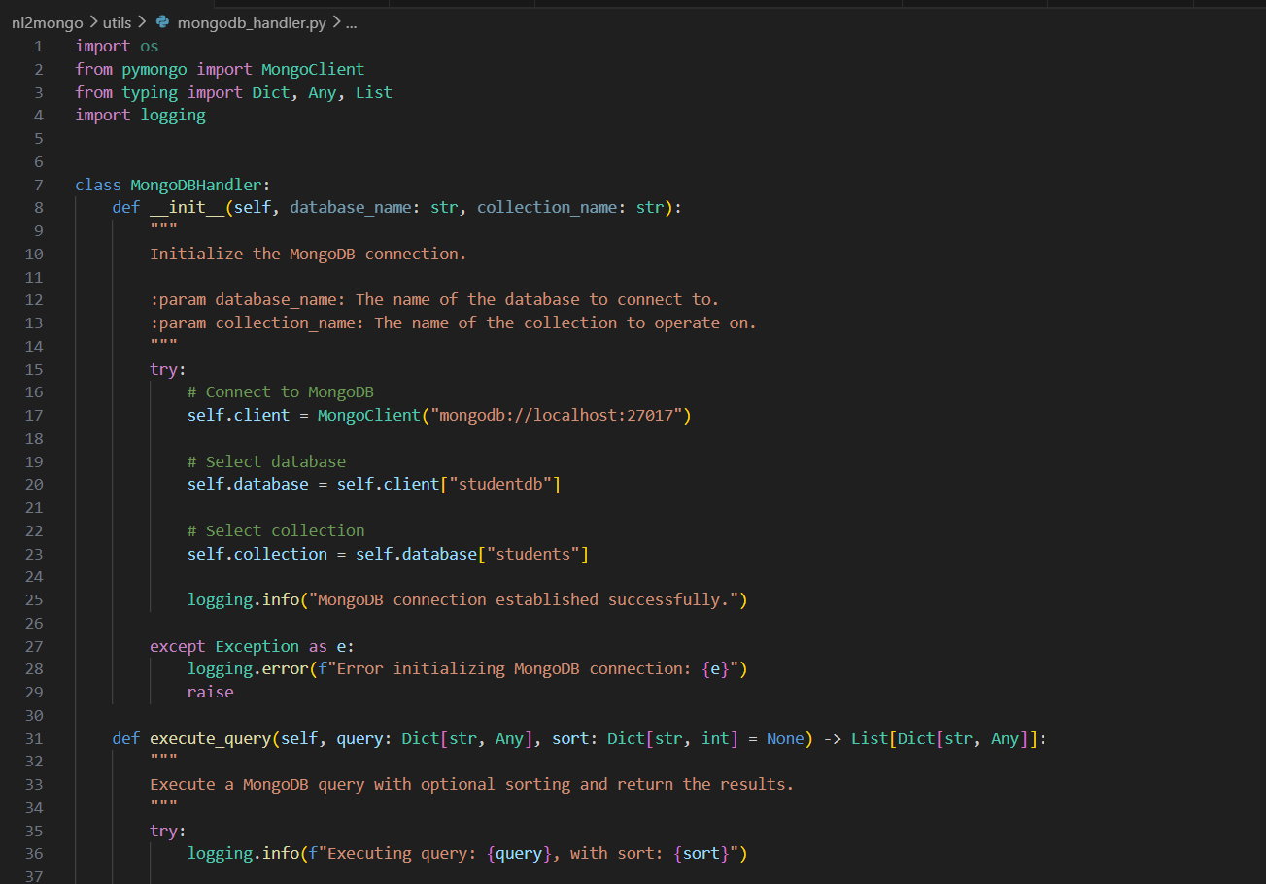
  - GitHub & Project Demo Link:
(https://github.com/jsaiteja4074/Natural-Language-Interfaces-for-Databases-Hack-N-Go-with-MongoDB/tree/main)
https://drive.google.com/file/d/1zMcrTQ8UZZc0bLA4SvkXdhb0PRzGJWig/view?usp=drive_link

